Power Electronics

Buck Converter

Taegeon Han & Jaehee Kim, Steel Hard

04/30/23

***Abstract* - The report describes the configuration and operation of the buck converter circuit. The Buck Converter is a device that adjusts the switching duty cycle to step down the input voltage. Buck converters are used in many devices to meet the rated voltage because they can stably lower the input voltage to the desired voltage with a low loss. Unlike the ideal theory, the actual Buck Converter implementation has a problem in that the current cannot flow from the drain to the source because the $V_{gs}$ value is smaller than $V_{gs\left(th\right)}$. To solve this problem, we need to use bootstrap circuits when we make buck converter circuits. Attach a capacitor between the gate and the source and give a gap between between the gate and the source. In order to design an appropriate Buck Converter, it is necessary to design a circuit that can avoid problems that may arise in actual circuit implementation. However, in this process, they face trade-off relationships such as increased product size and heat loss during filtering and switching. Through this study, you can know the difference between theory and practice and think about an appropriate Buck Converter design.**

1. INTRODUCTION

T

his report will confirm the configuration of the buck converter circuit and the operating principles. The buck converter is called a step-down converter for use by lowering the output voltage relative to the input voltage. Most electronic devices are supplied by DC voltage. However, the devices do not all have the same required voltage. Each unit has its own rated voltage and therefore requires a converter. If voltage drops are required, buck converters are often used because they are stable and suitable for lowering output voltage and reducing loss. The buck converter consists of a capacitor, an inductor, a diode, and a MOSFET that acts as a switch. The MOSFET switches to output through inductors and capacitors, which act as filters, reducing ripple and providing a stable output voltage. Also, It works as a low pass filter. Therefore, the high frequency component move to the ground and only low frequencies which are DC components pass through them. The diode is connected next to the MOSFET source and when off state, the diode receives current from the inductor to flow. The MOSFET can control the current while reducing the loss by quickly repeating on and off. You can also adjust the duty and frequency to the wanted voltage. However, when the current flows from drain to source in the MOSFET of the actual circuit, the $V_{gs}$ becomes smaller and does not work properly. To solve this problem, we use bootstrap, which increases the voltage momentarily. In this experiment, we check the change in output voltage through duty control and implement a buck converter using an inductor, capacitor, and diode MOSFET. In addition, we will observe the difference in voltage drop according to the Bootstrap element in the buck converter.

1. Parts specification of Buck Converter circuit

|  |  |  |
| --- | --- | --- |
| **Parts** | **Specification** | **Value** |
| Bootstrap | IR2125 | - |
| MOSFET | IRF830 | - |
| Gate driver | TC1426 | - |
| PWM generator | TL494 | - |
| Dual op-amp | TLE207X | - |
| $$R_{load}$$ | - | $$20[Ω]$$ |
| $$V_{in}$$ | - | $$12[V]$$ |
| Inductor | - | $$150[μH]$$ |
| Capacitor | - | $$1800[μF]$$ |

Table 1. Experimental device

1. Buck Converter Operation

The Buck converter consists of a switch and an LC low frequency passing filter. The following will explain the principle of operation of the switch and the LC low frequency passing filter.

1) Understanding SPDT Switch in Buck Converter

A SPDT switch can be used to create a power conversion circuit with negligible power loss. The switch output voltage $v_{s}(t)$ is equal to the converter input voltage $V_{g}$ when the switch is in position 1, and is equal to zero when the switch is in position 2. The position of the switch changes periodically, and vs has a square waveform with a constant frequency (constant period). The switch changes the dc component of the voltage. Recall from Fourier analysis that the dc component of a periodic waveform is equal to its average value. Hence, the dc component of $v_{s}(t)$ is

$$V_{s}=\frac{1}{T_{s}}\int_{0}^{T_{s}}{v_{s}\left(t\right)dt=DV_{g}}$$

Thus, the switch changes the dc voltage, by a factor equal to the duty cycle D. Because the power dissipated by the switch is ideally zero, we have succeeded in changing the dc voltage component, using a device that is ideally lossless.

Figure 1. SPDT switch which changes the dc voltage

2) Understanding L–C low-pass filter in Buck Converter



In addition to the desired dc component Vs, the switch output voltage waveform $v_{s}(t)$ also contains undesirable harmonics of the switching frequency. In most applications, these harmonics must be removed, such that the output voltage $v(t)$ is essentially equal to the dc component $V = V_{s}$. A low-pass filter can be employed for this purpose. Through inductor and capacitor, we can configure Low Pass Filter (LPF). Figure 2 illustrates a single-section $L–C$ low-pass filter.

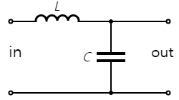

Figure 2. $L–C$ low-pass filter

The cut-off frequency of LPF can be obtained by the reactance of the inductor and the capacitance.

3) Understanding Buck Converter

The converter power stage configured with SPDT switch and $LC$ filter is called the buck converter, and it reduces the dc voltage.

Figure 3. Buck converter circuit

Several assumptions are need for the interpretation of Buck Converter.

First, the circuit is in Steady-State. In the buck converter, the current of the inductor goes through the trensient period when it is turned on. It is assumed that the circuit is in steady-state when interpreting the converter. When the converter operates in equilibrium:

Figure 4. Turn-on transient inductor current waveform

Second, Inductor curve is continuous (CCM). The discontinuous conduction mode arises when the switching ripple in an inductor current or capacitor voltage is large enough to cause the polarity of the applied switch current or voltage to reverse. Except where it is intentionally designed to operate in DCM, it is generally assumed and interpreted that the Buck converter operates in CCM mode.

Third, Capacitance is infinite. It is impossible to build a perfect low-pass filter that allows the dc component to pass but completely removes the components at the switching frequency and its harmonics. But if the capacitance is infinite, it can be seen that the cut-off frequency becomes 0 from the cut-off frequency equation above. This means that LPF passes only DC components. So, The output voltage v(t) is well approximated by its dc component V, with the small ripple term vripple(t) neglected:

$$v(t) ≈ V$$

Last, Input/Output voltages have same value.

Figure 5. dc transformer model

Since the LTI system is easy to interpret, we want to approximate the LTV system into an LTI system using the assumptions above. Switch circuits can be divided into two cases depending on the status of the switch and each can be interpreted as an LTI system. So the input voltage and output voltage operate linearly, as shown in Figure 6.

Figure 6. Buck converter dc output according to D

The following is a description of the operation of the circuit in each switch state.

i) Subinterval 1 (switch in position 1)

Figure 7. Buck converter circuit while the switch is in position 1

Figure 8. waveform of load voltage and inductor current of the Buck converter

$$v_{L}=V_{g}-v\left(t\right)≈V_{g}-V=L\frac{di_{L}(t)}{dt}$$

$$\frac{di_{L}(t)}{dt}=\frac{v_{L}\left(t\right)}{L}≈\frac{V_{g}-V}{L}$$

ii) Subinterval 2 (switch in position 2)

Figure 9. Buck converter circuit while the switch is in position 2

Figure 10. waveform of load voltage and inductor current of the Buck converter

$$v_{L}\left(t\right)=-v\left(t\right)≈-V=L\frac{di_{L}(t)}{dt}$$

$$\frac{di_{L}(t)}{dt}≈-\frac{V}{L}$$

iii) Inductor volt-second balance

The requirement that, in equilibrium, the net change in inductor current over one switching period be zero leads us to a way to find steady-state conditions in any switching converter: the principle of *inductor volt-second balance*. Given the defining relation of an inductor:

$$v_{L}\left(t\right)=L\frac{di_{L}(t)}{dt}$$

Integration over one complete switching period, say from t = 0 to $T_{s}$, yields

$$i_{L}\left(T_{s}\right)-i_{L}\left(0\right)=\frac{1}{L}\int_{0}^{T_{s}}{v_{L}\left(t\right)dt}=0$$

In steady state, the initial and final values of the inductor current are equal, and hence the left-hand side is zero. Therefore, in steady state the integral of the applied inductor voltage must be zero:

$$0=\int_{0}^{T_{s}}{v_{L}\left(t\right)dt}$$

The expression divided by the switching period Ts is also 0. This is the average value, or dc component, of .:

Figure 11. Inductor voltage waveform

The average value is therefore

$$〈v_{L}〉=\frac{λ}{T_{s}}=D\left(V_{g}-V\right)+D^{'}\left(-V\right)=DV_{g}-V=0$$

$$∴V=DV_{g}$$

The output voltage of the Buck converter is derived through the above processes. As Duty Cycle D is less than 0, the output voltage of the Buck converter is lower than the input voltage. And this equation means that we can control output voltage by value of D.

However, in real world, C is not infinite value. Therefore, ripple is existence. Ripple changed by D. The procedure for calculating the Ripple of the output voltage is as follows.

Figure 12. Capacitor current and voltage of Buck converter

Current $i_{C}(t)$ is positive for half of the switching period. This positive current causes the capacitor voltage $v_{C}(t)$ to increase between its minimum and maximum extrema. During this time, the total charge 푞is deposited on the capacitor plates, where

$$q=C\left(2Δv\right)$$

$$\left(change in charge\right)=C(change in voltage)$$

The total charge $q$ is the area of the triangle, as shown:

$$q=\frac{1}{2}Δi_{L}\frac{T_{s}}{2}$$

Eliminate $q$ and solve for $Δv$:

$$Δv=\frac{Δi_{L}T_{s}}{8C}=\frac{1}{LC}\frac{V(1-D)⋅T^{2}}{8}=\frac{1}{LC}\frac{{V_{g}(1-D)⋅D⋅T}^{2}}{8}$$

With the above expression, we can say that the value affecting the ripple is a ‘Ripple Factor’ and define it as follows.

$$Ripple Factor=\frac{ΔV}{V}=\frac{{(1-D)⋅T}^{2}}{8LC}=\frac{π^{2}}{2}\left(1-D\right){\left[\frac{f_{C}}{f_{s}}\right]}^{2}$$

$$\left(∵f_{s}=\frac{1}{T}, f_{C}=\frac{1}{2π\sqrt{LC}}\right)$$

$⇒$ If $f_{c}$ ↓ , Switching speed ↑ & Ripple ↓, but L & C ↑

$⇒$ If $f_{c}$ ↑ , number of Switching ↑ & Ripple ↓, but Heat Dissipation ↑.

Because of the above trade-off relationship, when we design Buck Converter, we need to set appropriate Inductance & Capacitance to set the given conditions.

1. RESULT

This section describes the experimental process. The signal and magnitude of the voltage are measured, and the resulting waveform's values are graphically represented using oscilloscopes and matlab. In the lab guidance, the following values are given.

$$f=150\left[kHz\right], R_{load}=20[Ω], V_{in}=12\left[V\right]$$

$$P_{out,max}=10\left[W\right], L=150[μH], C=1,800[μF]$$

$$∆V_{out}≤0.1\%∙V_{out}$$

The Buck Converter circuit was constructed with these values. we plug in the wall warts that are used to power the electrical components of the protobread. Voltage of the each is powered by the wall wart, and according to the above value, each chip receives a supply voltage of 12V. The duty value can be adjusted by adjusting the variable resistance of the circuit while receiving a constant supply voltage of 12V, and the signal and waveform of the voltage can be checked.

1. Buck converter without bootstrap

Now we show the result of load voltage and PWM according to the duty of the buck converter without bootstrap. This buck converter is composed of MOSFET, inductor, capacitor, and load resistance. The following figures are the result of a buck converter without a bootstrap.

Figure 13. Buck converter without bootstrap (D : 0.1)

Figure 14. Buck converter without bootstrap (D : 0.3)

Figure 15. Buck converter without bootstrap (D : 0.5)

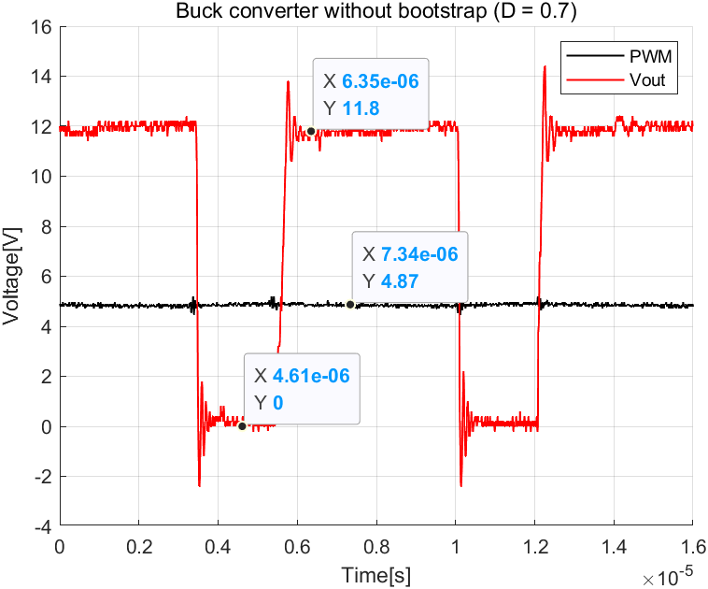

Figure 16. Buck converter without bootstrap (D : 0.7)

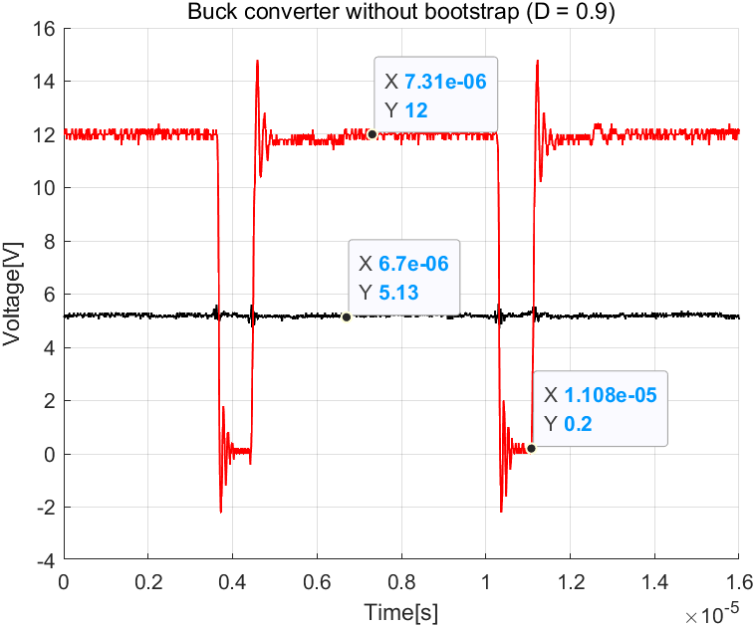

Figure 17. Buck converter without bootstrap (D : 0.9)

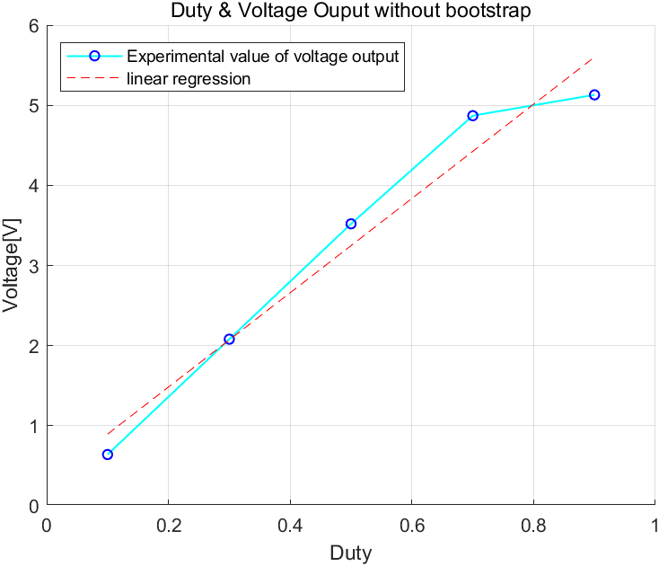

Figure 18. Voltage output of Buck converter without bootstrap

From the measured data, we can get the output voltage of the buck converter without the bootstrap to each duty. And through this, we can get the linear line about it. Therefore, the output voltage through duty is indicated as a single graph like Figure 18.

1. Buck converter with bootstrap

In this section, a bootstrap element was used for the buck converter circuit. Bootstrap increases the voltage between the gate and the source by adding a capacitor between the gate and the source of the MOSFET. Therefore, it can be observed that the result is closer to the ideal output voltage of the buck converter circuit. The following figure shows the result of a buck converter with bootstrap according to the Duty.

Figure 19. Buck converter with bootstrap (D : 0.1)

Figure 20. Buck converter with bootstrap (D : 0.3)

Figure 21. Buck converter with bootstrap (D : 0.5)

Figure 22. Buck converter with bootstrap (D : 0.7)

Figure 23. Buck converter with bootstrap (D : 0.9)

Figure 24. Voltage output of Buck converter with bootstrap

From the measured data, we can get the output voltage of the buck converter with the bootstrap according to each duty. And through this, we can get the linear line about it. Therefore, the output voltage through duty is indicated as a single graph like Figure 24.

1. Simulation of Buck converter

The buck converter was implemented as shown in Figure 3 using PSIM. The conditions of the simulation circuit were given the same as those of the circuit experiment and are assumed to be ideal as a whole. The following figure shows the simulation result of the buck converter according to Duty.

Figure 25. Simulation buck converter circuit

Figure 26. Simulation result(D : 0.1)

Figure 27. Simulation result(D : 0.3)

Figure 28. Simulation result(D : 0.5)

Figure 29. Simulation result(D : 0.7)

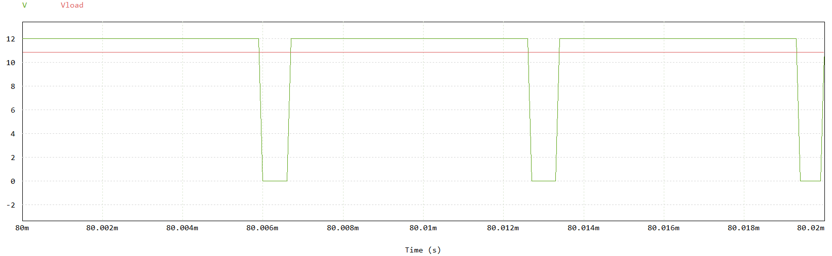

Figure 30. Simulation result(D : 0.9)

1. Comparison with A,B, and C of RESULT

|  |  |  |  |
| --- | --- | --- | --- |
| Duty | Experimental  Value of A[V] | Experimental  Value of B[V] | Simulation  Value [V] |
| 0.1 | 0.64 | 1.08 | 1.2 |
| 0.3 | 2.1 | 3.8 | 3.6 |
| 0.5 | 3.52 | 6.4 | 6 |
| 0.7 | 4.87 | 8.8 | 8.4 |
| 0.9 | 5.13 | 9.7 | 10.8 |

Table 3. Comparing the results

A is a buck converter without a bootstrap, B is a buck converter with a bootstrap, and C is a circuit made and operated by PSIM. The conditions of the simulation value are ideal, so they come out similar or the same as the theoretical value. The theoretical output voltage can be obtained by the following equation.

$$V_{out}=D×V_{in}$$

As a result of calculating the value according to Duty by using the equation, it was the same as the PSIM simulation value. When I checked the result value through Table 2, the result value was different depending on the presence or absence of Bootstrap. We confirmed that the buck converter with bootstrap was more like the simulation value than when there doesn't have a bootstrap.

1. Observation
2. Heat generation

By making the circuit of the buck converter, it was confirmed that the output voltage varies depending on the duty. During the experiment, heat was generated in the device and the device was often damaged. In a buck converter, increasing the duty cycle will generally increase the average output voltage, while decreasing the average output current. However, in our experiment, the current increased. This is because a current is related to an inductor, and as duty increases, the same amount of energy is transmitted to the power for a longer time. However, as the duty increases, the ON time of the MOSFET which acts as a switch is longer so the peak output current may increase. We didn't care about the current because we didn't think about this part. Therefore, elements such as the gate driver and the PWM used in the circuit didn't work. In the end, heat can be thought of as a power loss. The loss can be calculated in the following way.

$$P_{loss}=VI=\left(V_{in}-V_{out}\right)×I_{in}$$

The loss was also caused by a voltage drop in the buck converter. That is, when the Duty is high, a high output voltage is generated, and when the Duty is low, a low output voltage is generated. Therefore, when the Duty value is low, a high voltage drop occurs causing a large loss. Due to this loss, high heat affects the device and is broken. We can think of another reason that causes heat. In the case of OFF of MOSFET, the current passes through the diode, and heat is generated due to resistance, resulting in the loss. Also, in this case, the loss may occur while emitting energy stored in the inductor as an output. In addition, the resistance inside the capacitor can cause losses.

1. Bootstrap of buck converter

We compared the difference between the value with and without Bootstrap through the result above. As a result, the result value with Bootstrap was closer to the ideal value. The IR2125 Bootstrap used in this experiment solves the Buck converter's problem almost completely as follows. First, the signal from the PWM at the Buck converter enters the gate of the MOSFET and the current flows from the drain to the source. Between the gate and the source, there is a threshold voltage, $V_{gs\left(th\right)}$, and the current can flow only when Vgs is equal to or greater than the value of $V_{gs\left(th\right)}$. However, when the current flows from drain to source, $V_{gs}$ decreases as the source voltage increases and becomes less than $V_{gs\left(th\right)}$. Thus, the gate and the source of MOSFET operate like an open circuit, and no current flows between the drain and the source. Bootstrap is used to solve these problems. Bootstrap solves the problem through the Capacitor and Diode between the gate and the source. In Figure 31 (a), a gate voltage is generated as the input voltage of MOSFET through a diode is instantaneously charged in the capacitor when the high-side switch is off. Then, when the ON state is changed, a current does not flow in the direction of a diode as illustrated in Figure 31 (c), and as the voltage of the capacitor is $V_{s}$, a clear voltage difference is created between the gate and the source.

Figure 31. Bootstrap operation

1. Bootstrap performance

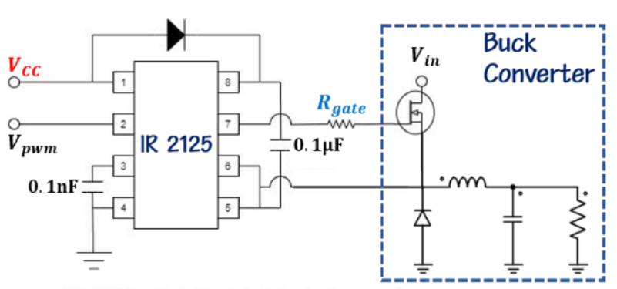

Figure 32. Bootstrap circuit

|  |  |  |  |
| --- | --- | --- | --- |
| Duty | Without Bootstrap voltage [V] | Theoretical voltage [V] | Error [%] |
| 0.1 | 0.64 | 1.2 | 46.67 |
| 0.3 | 2.1 | 3.6 | 41.67 |
| 0.5 | 3.52 | 6 | 41.33 |
| 0.7 | 4.87 | 8.4 | 42.02 |
| 0.9 | 5.13 | 10.8 | 52.5 |

Table 3. Output voltage of buck converter without Bootstrap and Ideal

According to duty, Table 3 shows a table comparing the power voltage theoretically calculated or through experiments of a buck converter without a bootstrap. There is a large error of approximately 40-50% between these two values. We assumed this is because there is a threshold voltage, $V_{gs\left(th\right)}$, between the gate and the source terminal of the MOSFET and there is no voltage difference between the gate and the source, so $V_{gs}$ is smaller than $V_{gs\left(th\right)}$

.

In the end, since the source is connected to the inductor not ground, floating voltage occurs which inevitably causes the above problems. Therefore, it is necessary to be able to make the voltage difference between gate and source. To solve this, we use Bootstrap to make it more than $V_{gs\left(th\right)}$. The voltage of the gate terminal was increased using the Capacitor, and a voltage difference was created between the gate and the source. As shown in Figure 20, the bootstrap was connected to the MOSFET to create a circuit that solved the above problem Table 4 compares the output voltage of the experimental value and the theoretical value.

|  |  |  |  |
| --- | --- | --- | --- |
| Duty | With Bootstrap voltage [V] | Theoretical voltage [V] | Error [%] |
| 0.1 | 1.08 | 1.2 | 10 |
| 0.3 | 3.8 | 3.6 | 5.56 |
| 0.5 | 6.4 | 6 | 6.67 |
| 0.7 | 8.8 | 8.4 | 4.76 |
| 0.9 | 9.7 | 10.8 | 10.19 |

Table 4. Output voltage of buck converter with Bootstrap and Ideal

In Table 4, it can be seen that the error between the experimental value and the theoretical value is about 0-10%. Compared to Table 3 about buck converter without bootstrap, the error was very small. Through this, it was confirmed through experiments that the floating voltage was solved through bootstrap, if not completely, and the output power voltage was almost similar to the theoretical value.

# CONCLUSION

In this experiment, a buck converter circuit was designed and implemented. Under the given conditions, the Duty value was adjusted using variable resistance in the circuit to get the desired power voltage, and the power voltage was stably derived using the Capacitor and inductor, which play the role of filtering. A buck converter may occur heat loss depending on duty, as a voltage drops and a device may not operate normally. A buck converter occurs voltage drops according to Duty. Also, It may make heat loss which may cause the device to fail to operate normally. In addition, when the buck converter was actually implemented, the $V_{gs}$ of the MOSFET device decreased and became smaller than $V_{gs\left(th\right)}$, so that the current could not flow from the drain to the source. To solve this problem, Bootstrap which creates a voltage difference between the gate and the source was used. Compared to the buck converter without bootstrap and the theoretical value, the error rate was about 40% to 50%. However, the error rate between the buck converter with Bootstrap and the theoretical value was reduced to 0-10%. Through this, the voltage difference according to the Bootstrap device was observed, and it was concluded that even if Bootstrap was used, it could not be perfectly matched with the theoretical value.

# WORK DISTRIBUTION

|  |  |  |
| --- | --- | --- |
|  | Kim, Jaehee | Han, Taegeon |
| Circuit construction | 50% | 50% |
| Circuit Testing | 50% | 50% |
| Report | 50% | 50% |

# PROBLEMS

**Problem 1)**

Draw waveforms of diode voltage, MOSFET current & voltage, inductor current & voltage, capacitor current & voltage and load current.

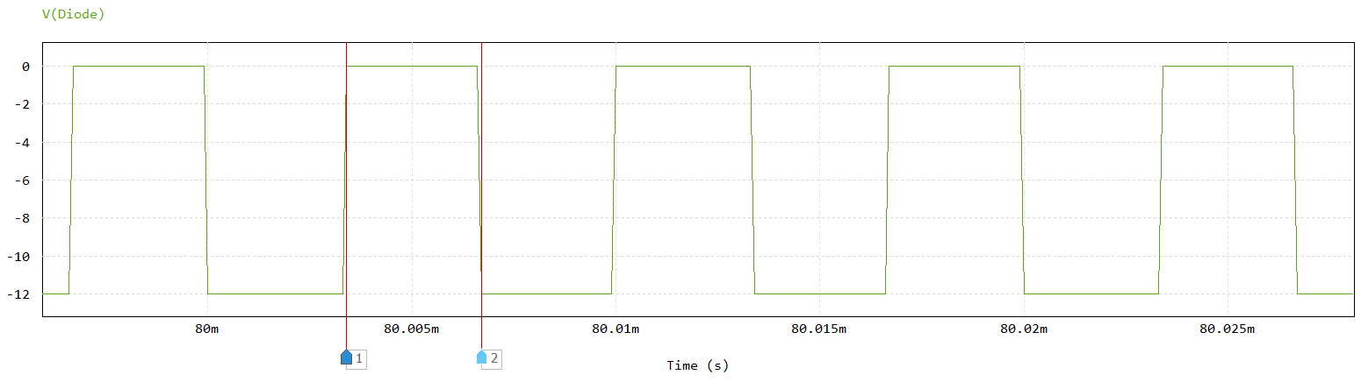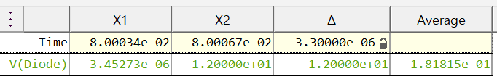

Figure 33. Diode voltage

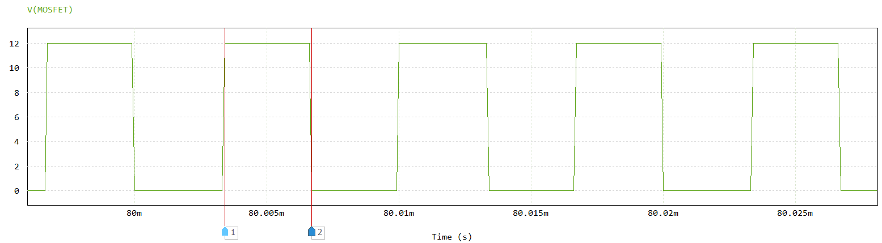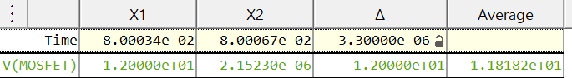

Figure 34. MOSFET voltage

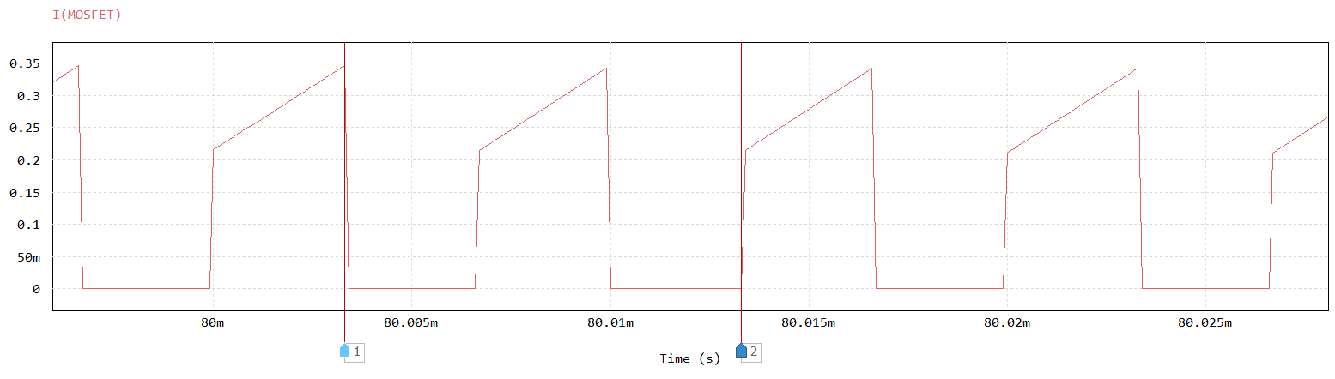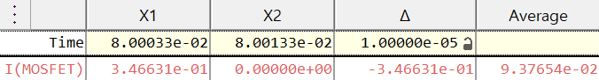

Figure 35. MOSFET current

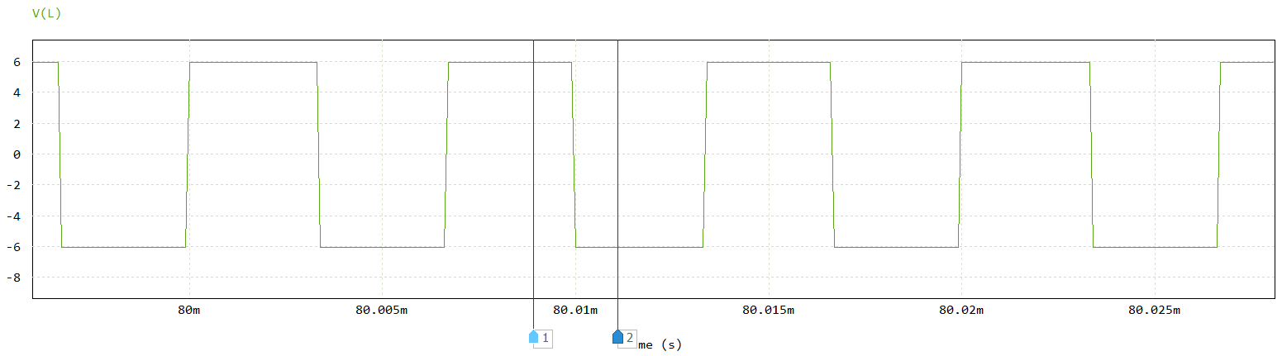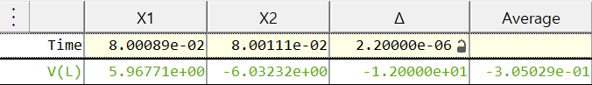

Figure 36. Inductor voltage

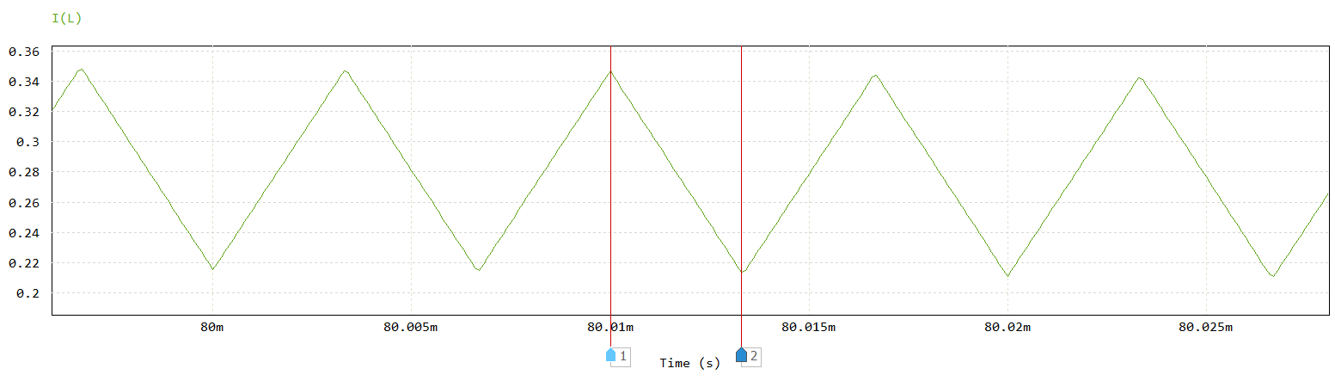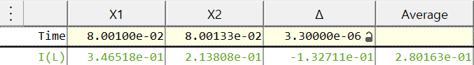

Figure 37. Inductor current

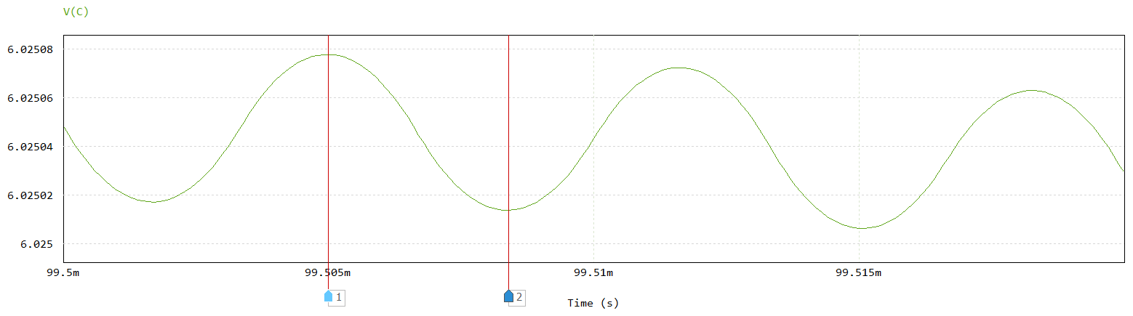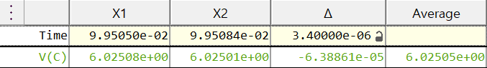

Figure 38. Capacitor voltage

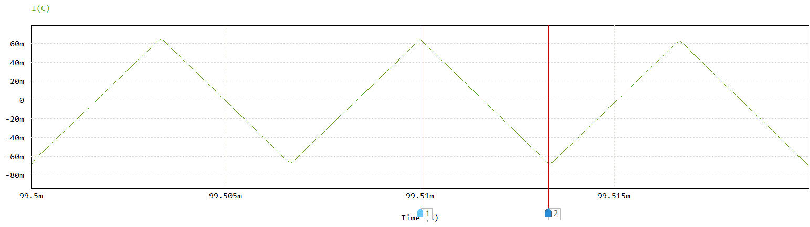 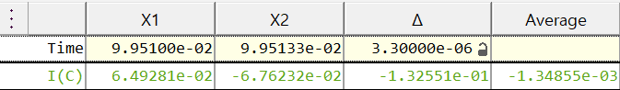

Figure 39. Capacitor current

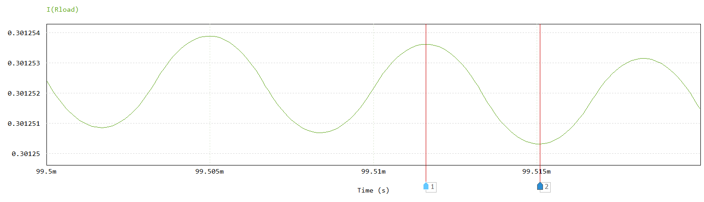 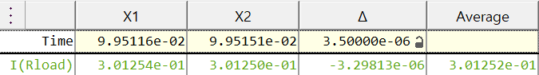

Figure 40. Load current

**Problem 2)**

Current waveform in steady state in an inductor of 50 $μH$. Draw a waveform of the inductor voltage waveform.

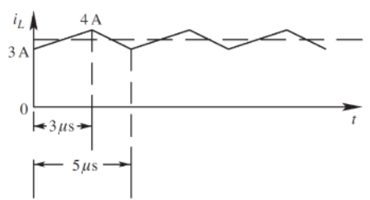

Figure 41. Current waveform of Problem 2

Sol)

We can fine the following value through Figure 40.

$$∆i=1A, T_{s}=5μs, D=0.6$$

The $V_{in}$ can be found using the above value, and if the $V_{in}$ is applied to the circuit, the inductor voltage waveform can be obtained by following equations.

$$V_{out}=D×V_{in}=0.6×V_{in}$$

$$∆i_{L}=\frac{V_{in}-V_{out}}{L}×D×T_{s}=\frac{0.4V_{in}}{50μ}×0.6×5μ=1$$

$$V_{in}=41.6667[V]$$

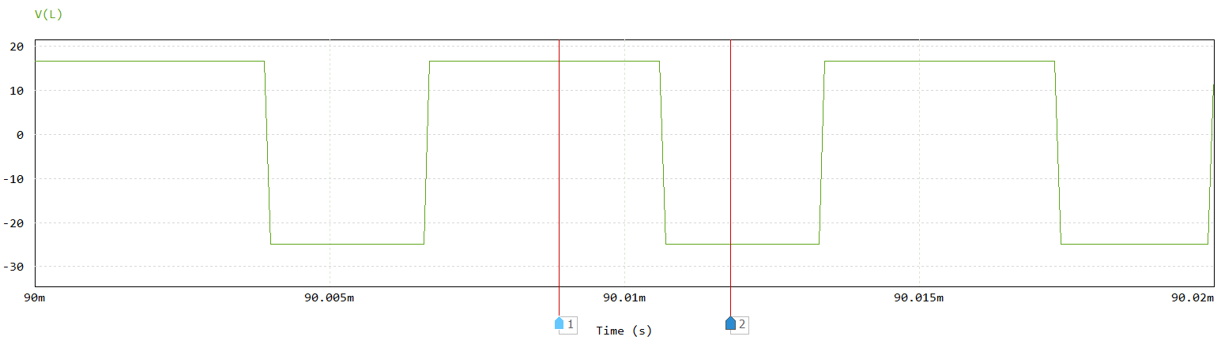

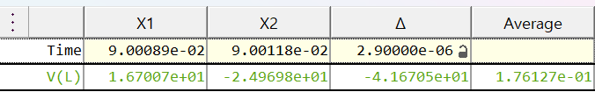

Figure 42. Inductor voltage waveform

**Problem 3)**

The capacitor current $i_{c}$, shown in Fig. 9, is flowing through a capacitor of 100[$μF$]. Calculate the peak-peak ripple in the capacitor voltage waveform due to this ripple current.

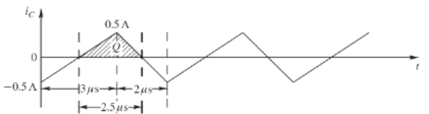

Figure 43. Current waveform of problem 3

Sol)

We can fine the following value through Figure 43.

$$∆i_{L}=1A, T_{s}=5μs$$

Peak-peak ripple can be found using the above value and the following equation.

$$∆V=\frac{∆i_{L}T_{s}}{8C}=\frac{1×5μ}{8×100μ}=6.25[mV]$$

**Problem 4)**

From the PSIM Circuit of the Buck converter shown in Fig. 25, Inductor 24[$μ$ H]. It is operating in dc steady state under the following conditions: 𝑉𝑖𝑛 = 20𝑉 𝐷 = 0.6, 𝑃𝑜𝑢𝑡 = 14[W], and frequency = 200[kHz]. Assuming ideal components, calculate and draw the waveforms of the inductor current and voltage.

Sol)

We can find ideal components by following equations.

$$V_{out}=D×V_{in}=0.6×20=12\left[V\right]$$

$$∆i_{L}=\frac{V_{in}-V_{out}}{L}×D×T_{s}=\frac{V_{in}-V_{out}}{L}×D×\frac{1}{f}$$

$$∆i_{L}=\frac{20-12}{24μ}×0.6×\frac{1}{200k}=1[A]$$

$$I_{L}=\frac{P_{out}}{V_{out}}=\frac{14}{12}=1.16667[A]$$

$$I_{Lmax}=I_{L}+\frac{∆i_{L}}{2}=1.66667[A]$$

$$I_{Lmax}=I_{L}-\frac{∆i_{L}}{2}=0.66667[A]$$

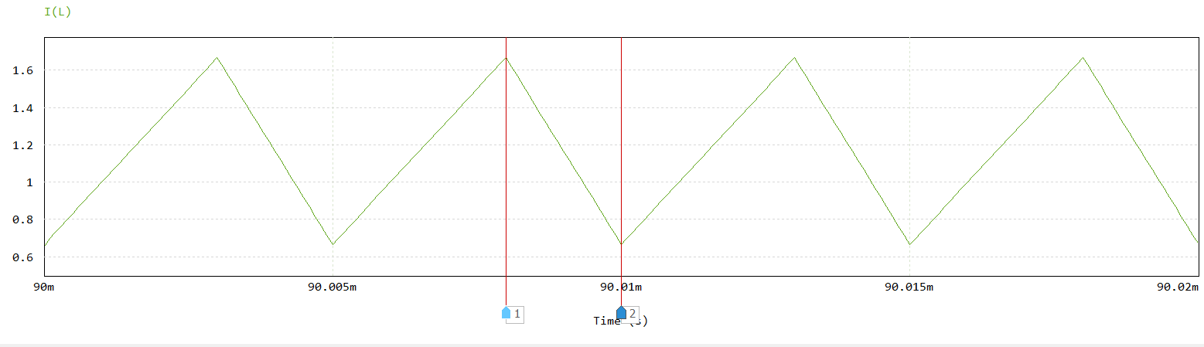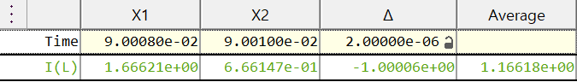

Figure 44. Inductor current waveform

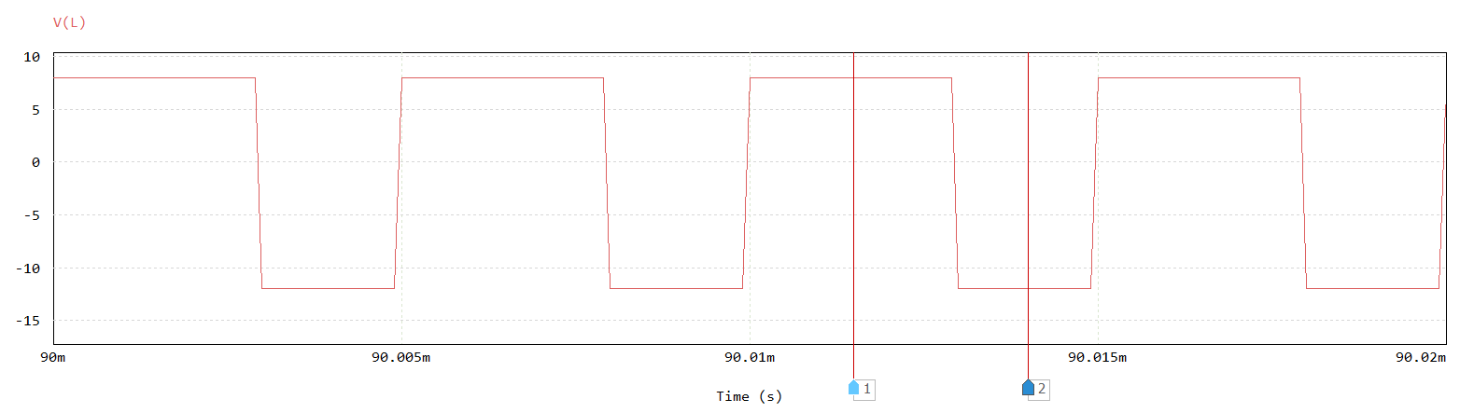 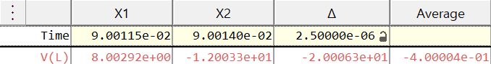

Figure 45. Inductor voltage waveform

**Problem 5)**

In a Buck dc-dc converter, L=25 μH. It is operating in dc steady state under the following conditions: V_in=42 V, D=0.3, and f=400 kHz. Assume ideal components. The output load is changing. Calculate the critical value of the output load R_load and P_out below which the converter will enter the discontinuous conduction mode of operation.

Sol)

$I_{out}$ must be less than $Δi_{L}$ to enter the discontinuous conduction mode of operation. When calculated by the threshold

Figure 46. Inductor voltage waveform CCM-DCM boundary

$I_{out}=\frac{V_{out}}{R_{load}}$, $R_{load}=\frac{V_{out}}{I_{out}}=\frac{D⋅V_{in}}{Δi_{L}}$

$$V_{out}=D⋅V_{in}=12.6[V]$$

$$Δi_{L}=\frac{V_{in}-V_{out}}{2L}DT_{s}$$

$$=\frac{42-12.6}{2×25⋅{10}^{-6}}×0.3×\frac{1}{400⋅{10}^{3}}=0.441[A]$$

$$R_{load}=\frac{D⋅V_{in}}{Δi_{L}}=\frac{12.6}{0.441}=28.57[Ω]$$

$$P_{out}=V_{out}I_{out}=\frac{V_{out}^{2}}{R_{load}}=\frac{{12.6}^{2}}{28.57}=5.557[W]$$

**Problem 6)**

A Buck dc-dc converter is to be designed for $V_{in}$ =20 V, $V_{out}$ =12 V, and the maximum output power $P_{out}$ =72 W. The switching frequency is selected to be $f$ = 400 kHz. Assume ideal components. Estimate the value of the filter inductance that should be used if the converter is to remain in CCM at one-third the maximum output power.

Sol)

$$D=\frac{V_{out}}{V_{in}}=\frac{12V}{20V}=0.6$$

$$T_{s}=\frac{1}{f_{s}}=\frac{1}{400kHz}=2.5μs$$

$$Δi_{L}=\frac{V_{in}-V_{out}}{L}DT_{s}$$

The ripple current $Δi_{L}$ must be less than the output current $I_{out}$ to remain in CCM. When calculated by the threshold $I_{out}=Δi_{L}$

$$P_{out}=V_{out}I_{out}=V_{out}Δi_{L}$$

$$L=\frac{V_{in}-V_{out}}{2Δi_{L}}DT_{s}=V_{out}^{2}×\frac{\left(1-D\right)T_{s}}{2(\frac{1}{3}P_{out})}$$

$$={12}^{2}×\frac{\left(1-0.6\right)×2.5⋅{10}^{-6}}{2×\frac{1}{3}⋅72}=3⋅{10}^{-6}=3[μH]$$

# APPENDIX

Figure 47. Buck converter circuit with bootstrap

Figure 48. Buck converter circuit without bootstrap

Figure 49. MATLAB code of result graphs

Figure 50. MATLAB code of output trend line graphs

# REFERENCE

[1] Robert W Maksimovic Dragan Erickson - Fundamentals of Power Electronics.-Springer nature(2020)

[2] Surinder P. Singh, Ph.D., Manager, Power Applications Group - Output Ripple Voltage for Buck Switching Regulator, Texas Instruments, Application Report(2014, October)